RETAIL BANKING

BANKING HISTORY

History & Barter System

The History of Banking in India dates back to before India got independence in 1947

The banking sector development can be divided into three phases:

**Phase I:**The Early Phase which lasted from 1770 to 1969

**Phase II:** The Nationalisation Phase which lasted from 1969 to 1991

**Phase III:** The Liberalisation or the Banking Sector Reforms Phase which began in 1991 and continues to flourish till date

Given below is a pictorial representation of the evolution of the Indian banking system over the years:

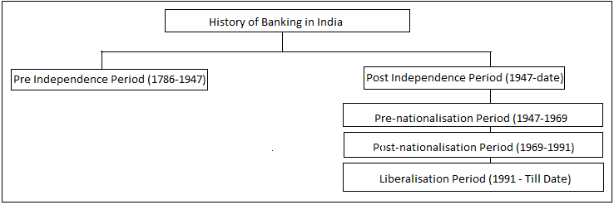

Pre Independence Period (1786-1947)

The first bank of India was the “*Bank of Hindustan*”, established in 1770 and located in the then Indian capital, Calcutta. However, this bank failed to work and ceased operations in 1832.

Following the path of Bank of Hindustan, various other banks were established in India. They were:

* The General Bank of India (1786-1791)
* Oudh Commercial Bank (1881-1958)
* Bank of Bengal (1809)
* Bank of Bombay (1840)
* Bank of Madras (1843)

## Post Independence Period (1947-1991)

At the time when India got independence, all the major banks of the country were led privately which was a cause of concern as the people belonging to rural areas were still dependent on money lenders for financial assistance.

With an aim to solve this problem, the then Government decided to nationalise the Banks. These banks were nationalised under the Banking Regulation Act, 1949. Whereas, the Reserve Bank of India was nationalised in 1949.

Given below is the list of these 14 Banks nationalised in 1969:

1. Allahabad Bank
2. Bank of India
3. Bank of Baroda
4. Bank of Maharashtra
5. Central Bank of India
6. Canara Bank
7. Dena Bank
8. Indian Overseas Bank
9. Indian Bank
10. Punjab National Bank
11. Syndicate Bank
12. Union Bank of India
13. United Bank
14. UCO Bank

## Liberalisation Period (1991-Till Date)

Once the banks were established in the country, regular monitoring and The biggest development was the introduction of Private sector banks in India. RBI gave license to 10 Private sector banks to establish themselves in the country. These banks included:

1. Global Trust Bank
2. ICICI Bank
3. HDFC Bank
4. Axis Bank
5. Bank of Punjab
6. IndusInd Bank
7. Centurion Bank
8. IDBI Bank
9. Times Bank
10. Development Credit Bank

regulations need to be followed to continue the profits provided by the banking sector. The last phase or the ongoing phase of the banking sector development plays a hugely significant role.

Barter System

Barter is an old method of exchange before money was not so common. A simple example of the barter trade is a carpenter who builds furniture for a farmer, where the farmer compensates for his service with grains. Though being a very ancient and inefficient method when money is easily available, you can still find it in some rural areas in its primitive form.

How it works

Barter economies are one of the earliest forms of economic activities, predating monetary systems and even written history. People have used barter successfully in practically every field. Informally, people frequently engage in barter and other reciprocal systems without realising it. For instance, providing a homeowner with web design or technical services for a rent-free stay.

Because barter relies on reciprocity, it needs traders to have mutually compatible desires. This requirement complicates barter, but in a large enough system, barter can meet most needs. One advantage of bartering is that people do not exchange money. You can purchase stuff by exchanging one item you no longer want for another.

Gift Economy

A **gift economy** or **gift culture** is a system of exchange where valuables are not sold, but rather given without an explicit agreement for immediate or future rewards. Social norms and customs govern giving a gift in a gift culture; although there is some expectation of reciprocity, gifts are not given in an explicit exchange of goods or services for money, or some other commodity or service. This contrasts with a barter economy or a market economy, where goods and services are primarily explicitly exchanged for value received.

Central Bank

A **central bank**, **reserve bank**, or **monetary authority** is an institution that manages the currency and monetary policy of a country or monetary union. In contrast to a commercial bank, a central bank possesses a monopoly on increasing the monetary base. Many central banks also have supervisory or regulatory powers to ensure the stability of commercial banks in their jurisdiction, to prevent bank runs, and in some cases also to enforce policies on financial consumer protection and against bank fraud, money laundering, or terrorism financing.

Indian Banking System, Functions, Types

The banking system of India consists of the RBI, commercial banks, cooperative banks and development banks (development finance institutions). These institutions, which provide a meeting ground for the savers and the investors, form the core of India’s financial sector. Through mobilization of resources and their better allocation, banks play an important role in the development process of underdeveloped countries.

Banks play a major role in a country's economic development. In India, Banks are regulated by the Reserve Bank of India also called as Central Bank. Its main function is to accept deposits from the public and lend those deposits in the form of loans for the development of Agriculture, Industry, Trade, and Commerce.

* Banks play an important role in providing loans to generate profits and manage risks.
* This will generate economic growth and build a good relationship with customers.
* Providing loans will support the fulfillment of essential needs of consumers and businesses.
* This will create a positive impact on the economy.

The functions of banks are primarily classified into two types. Their types are given below,

* **Primary Functions:**

The primary functions of bank are **Accepting Deposits, and Granting Advances.**

* **Secondary Functions:**

The secondary functions of bank are providing **Agency Functions and Utility Functions.**

In India, Banks are classified into eight types. The list of different types of banks in India is explained below.

* Central Bank of the country
* Cooperative Banks
* Commercial Banks
* Regional Rural Banks
* Local Area Banks
* Financial Institutions in India (Specialized Banks)
* Small Finance Banks
* Payments Banks

Business Model

The business model of Banks is

* Give loans, earn interest (revenue).
* Accept deposits, pay interest (cost).
* Earned interest minus paid interest is profit.

Banks also make money from the other sources like:

* Distribution of mutual funds.
* Distribution if insurance schemes.
* Offering wealth management services.
* Treasury operations (buying/selling debt securities).

Cooperative and Commercial Bank

Cooperative banks are small financial institutions that work on the principle of cooperation. Cooperative banks are started by a group of people in order to support the financial needs of a village or a specific community. Cooperative banks are owned and operated by those members who gather resources and provide banking services like savings, loans, etc. Cooperative Banks play an important role in providing credit to agriculture, small industries, and other rural sectors. The Reserve Bank of India, the State Government, and NABARD also regulate Cooperative Banks. Cooperative banks are classified into two categories. They are,

1. **Agricultural Credit Institutions**
2. **Non-Agricultural Credit Institution**

Commercial Banks are the profit making institutions of the country that accepts deposits from the general public and lends money in the form of loan to individuals like normal people, entrepreneurs, businessmen, etc. The main aim of commercial banks is to earn a profit by the interest from the given loans. Commercial Banks are regulated by the central bank, the Reserve Bank of India which is the supreme financial authority of India.

The Commercial Banks are classified into various types. They are explained below,

* Scheduled Banks
* Public Sector Banks
* Private Sector Banks
* Foreign Banks
* Non scheduled commercial Banks

Retail Liabilities

Retail Banking Overview

Retail banking, also known as consumer banking or personal banking, is banking that provides financial services to individual consumers rather than businesses. Retail banking is a way for individual consumers to manage their money, have access to credit, and deposit their funds in a secure manner.

Products & Services offered

Some of the services and products offered by retail banks include

### **Bank Account Opening**

### **Deposits**

### **Loans**

### **Cards**

### **Investment and Insurance**

### **Other Services**

Savings & Current Account – Features

A Savings Account is the most common product offered by any bank in India. It is a fundamental type of bank account with a straightforward idea of depositing & withdrawing money, if and when required.

Below are some of the classic features of a Savings Account:

### Quick & easy financial transactions

### Interest earnings

### ATM and Debit Card facility

### Passbook and cheque facility

### Net Banking and Mobile Banking

### Minimum Average Balance

### Account type

A Current Account is a non-interest-bearing bank account, mainly used to service the needs of the businesses. Current Accounts allow for more transaction limits on cash deposits and withdrawal within or outside city. Current Account can be opened by individuals, sole proprietorships, partnership firms, private and public limited companies, HUFs/ specified associations, Societies, Trusts etc.

Below are some of the classic features of a Current Account:

The Current Account is a non-interest-bearing account

Enables higher cash deposits & withdrawals within or outside city

Overdraft Facility available to businesses based on business transactions, financial documents and average balance maintained in the account

The minimum balance requirement varies as per the type of Current Account

Enjoy extended banking hours^ for carrying out transactions

Avail Debit Card facility based on the Current Account packages

Advances, Discounting, Cash credit, and overdraft

Advances

Advances are issued by banks to address short-term financial needs; they are repaid within one year. ‘Advances’ refer to working capital finance extended by the bank to meet day to day requirements of the borrower. The overdraft facility, drawing against uncleared effects, cash Credit facility, packing credit (running account) facilities; Bills finance facilities, credit card facilities, cheques purchase,  etc., are some examples of advances.

Cash credit

Cash credit is referred to as short-term funding or loan for a company so that it can meet its working capital requirements. Cash credit is a sort of loan that is offered to businesses by financial institutions like banks. Banks offer cash credit to businesses based on the latter's credit history and financial stability. If you procure funds via cash credit, you can use it for various business-related purposes like expansion, purchasing plant and machinery, raw materials, hiring staff, debt consolidation, etc.

Overdraft

An overdraft occurs when there isn't enough money in an account to cover a transaction or withdrawal, but the bank allows the transaction anyway. Essentially, it's an extension of credit from the financial institution that is granted when an account reaches zero. The overdraft allows the account holder to continue withdrawing money even when the account has no funds in it or has insufficient funds to cover the amount of the withdrawal. Basically, an overdraft means that the bank allows customers to borrow a set amount of money

Deposit services: Types and features

Fundamentally, a deposit is money held by a bank. The money that you put for savings in your bank account for any reason. It could be to safeguard your money, increase your savings, or money received via cheques and other forms of fund transfers – all come under the umbrella of deposits. Every time a transaction involves a fund transfer into your bank account, it is referred to as a deposit payment.

Types of deposits

Deposits are broadly classified into two types:

### Demand Deposit

### Time Deposit

Features

The important features of bank deposits are as follows :

1. The interest rate on fixed deposits varies with the term of the deposit. In general, it is lower for fixed deposits of shorter term and higher for fixed deposits of longer term.
2. If the deposit is less than 90 days, the interest is paid on maturity, otherwise it is paid quarterly.
3. Loans can be raised against bank deposits.
4. Bank deposits are fairly safe because banks are subject to control of the Reserve Bank of India with regard to several policy and operational parameters.
5. The rate of interest may change from time to time according to the rules of Reserve Bank of India.
6. There is a ceiling on the interest rate payable on deposits in the savings account.
7. Most banks calculate interest on the minimum deposit between the 10th and the last date of the month.
8. Bank deposits enjoy exceptionally high liquidity. They can be enhased prematurely by incurring a small penalty.

Retail Assets

Retail Asset Products Overview

Some of the retail asset products includes

* Home loan
* Vehicles loan
* Personal loan
* Education loan

Credit Origination system for individuals

**Credit Origination** is the process by which a lender or other credit granting institution approves for a new credit product or exposures (such as a new loan, mortgage, credit card etc) and performs initial processing. Origination starts with an application from a new or existing client and (for approved transactions) ends with the remittance of any upfront monies and the integration of the new exposure into the existing Credit Portfolio.

The precise steps involved in credit origination will vary by market, product (including whether it is secured by collateral, the size of exposure etc). Regulatory requirements and guidelines will in general apply.

Understanding the workflows and Business rule engine

Below is the workflow process of a Credit origination

###### Pre-Qualification Process

‍**Loan Application**

###### **Application Processing**

‍**Underwriting Process**

**Credit Decision**

**Quality Check**

**Loan Funding**

Key Business Process in Credit origination system

###### Pre-Qualification Process

‍**Loan Application**

###### **Application Processing**

‍**Underwriting Process**

**Credit Decision**

**Quality Check**

**Loan Funding**

Credit Origination System for SMEs/Corporates

Small and medium enterprise (SME) loans are an important revenue stream for banks. SME clients are looking for banks that offer friction-free account opening, fast loan funding, and solutions that empower growth.

The SME loan origination solution is designed to make personalized loan product offers for a bank’s small and medium-sized commercial customers and prospects when they apply for a loan to expand and operate the business. The process involves requesting, prescreening, underwriting, onboarding, and approvals from banks. At many banks this process is siloed, heavily manual, labor intensive, and cost intensive. It is subject to human error, data quality concerns, and auditability issues. Loan origination often consists of monolithic business processes that are rigid and hard to tune, which makes it difficult to accommodate changing business needs.

Loan servicing system – Key concepts

Loan servicing refers to the administrative aspects of a loan from the time the proceeds are dispersed to the borrower until the loan is paid off. Loan servicing includes sending monthly payment statements, collecting monthly payments, maintaining records of payments and balances, collecting and paying taxes and insurance (and managing escrow funds), remitting funds to the note holder, and following up on any delinquencies.

Key concepts

* Loan servicing is a function carried out by the bank or financial institution that issued the loan, a third-party vendor, or a company that specializes in loan servicing.
* Loan servicing functions include collecting monthly payments, paying taxes, and other aspects of the loan that occur from the time the proceeds are dispersed until the loan is paid off.
* Securitization of loans made loan servicing less profitable for banks.
* Loan servicing is now an industry in and of itself and companies are compensated by receiving a small percentage of loan payments.

Loan servicing system - Interest rate management

Interest rate risk exists in an interest-bearing asset, such as a loan or a bond, due to the possibility of a change in the asset's value resulting from the variability of interest rates. Interest rate risk management has become very important, and assorted instruments have been developed to deal with interest rate risk.

Interest Rate management Techniques are as follows

* Asset and Liability management(ALM)
* Interest rate hedging strategies
* Diversification of Assets and Liabilities
* Duration Matching

Debt Management system – Basic concepts Stages of collections

Debt management is a way to get your debt under control through financial planning and budgeting. The goal of a debt management plan is to use these strategies to help you lower your current debt and move toward eliminating it.

The **stages of collection** refer to time-based milestones and related activities that happen after a missed payment. Companies define these phases differently, based on their payment cycle. They will identify overdue payers and group them into repayments that are 1 to 30 days, 30 to 60 days, and 60 to 90 days past due

Here is a few strategic approach involving four stages of Debt collection

* Early delinquency
* Late delinquency
* Legal Action
* Recovery

Customer Onboarding

What is Customer On-Boarding

Customer onboarding is the process of actively nurturing and guiding new customers with the purpose of acclimating them to your products and services

Traditional Approach

Traditional onboarding — also known as **on-site, or in-person onboarding** — is the conventional process: A new customer visits a store or office to buy your product or sign up for your service.

Unlike digital onboarding, customers are required to be physically present in order to complete the onboarding requirements like verifying their identity, providing personal information, or filling out required forms.

Current Challenges

* Lack of understanding about the product or service
* Lengthy sign-up process
* Unclear instructions and documentation
* Ineffective communication with users
* Limited customer support

A digital approach to customer onboarding

Digital onboarding, also called remote onboarding, is the process of using online tools and software to get new customers added to your database or CRM.

Throughout the process, customers are able to get familiar with your product or service from wherever they're located, rather than in your store or office.

Types of digital identity checks

### Document Verification

### Address Verification

### Knowledge-Based Authentication (KBA)

### 2-Factor Authentication (2FA)

### Face Verification

E KYC for Individuals–India based

E KYC or Online KYC is the process of electronically verifying the authenticity of the customer

AADHAR enabled validations

Aadhaar based KYC verification follows the regulations of The Unique Identification Authority of India (UIDAI) and verifies proof of identity and residence through one’s Aadhaar number. In addition, the UIDAI provides information to service providers to activate customer services such as bank accounts, mobile connections, etc.

The Aadhaar based KYC authenticates data in two different ways

**OTP-based**

**Biometric-based**

Corporate e-KYC onboarding basic concepts

Corporate KYC is the process of validating identity of business & their owners in regards with KYC compliance. Click to know more about KYC requirements for corporates!

The goal of corporate KYC (know your customer) procedures is to ensure that financial institutions understand who their clients are. According to the standard operating procedures, the user must complete KYC before forming any working relationship with a financial institution

Banking Architecture

Banking Architecture Overview

The definition of banking architecture can be summarized as the applied frameworks that banks use, and those that customers and employees traverse through, in order to provide and procure banking services. If a bank is a large room, then banking architecture can be seen as the design of that room. The function, furniture, and style of the room all affect how those who work at the bank and those who wish to use it navigate their experience. Whether they move around with ease or with difficulty depends on the quality of the design

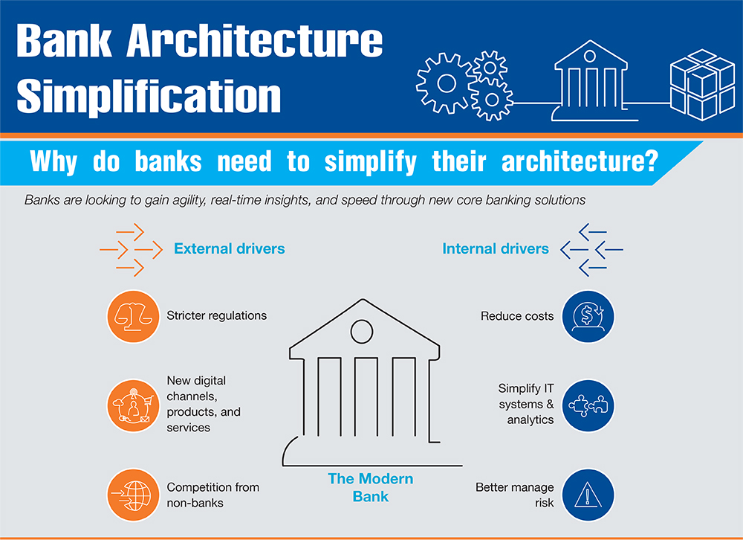

Legacy Systems

Legacy core banking systems are often decades old, mainframe based platforms that support a bank’s back end operations across core functions such as account opening, account set up, transaction processing, deposits processing, loan processing and more. Due to legacy technology, proprietary data models, and limited ability to interface with other systems, legacy systems can restrict a bank’s ability to rapidly deliver new experiences, products and services.

Modern Day Architecture

To gain insights from the generated data and act in real time, modernization has become an essential factor to future success. Moreover, as open banking becomes an API standard for sharing of data and services, the legacy systems cannot keep up with digital technology requirements and consumer data sovereignty rights that vary by country or geopolitical region.

Automation of human-centric processes is becoming increasingly critical with cloud native apps and customer-facing capabilities needing to be developed or modified at speed. Many banks are responding by adopting API-based ecosystems to manage critical integrations to new software, upgrades to current platforms, vulnerability remediation and application performance optimization.

When considering a modern banking platform design, there are three primary technical enablers. Cloud native architecture Agile, scalable, highly available Reduces IT costs and enables agile development Outcomes Attributes Open or API-first approach Modular, collaborative, seamless Facilitates integration of banking services with open banking in mind Data-enriched design Integrated customer view, data-based insights, future-proof Enables personalized experiences and use of advanced analytics

Simplifying Banking Architecture

To develop a customer centric banking platform, banks will need simplify their current architecture, ensuring data consistency and the integrity of various processes

Drivers for Bank Architecture simplification

External Drivers

* Regulations
* Competitive differentiation
* New channels, Products and Services

Internal Drivers

* Cost Reduction
* IT simplicity and improved analytics
* Risk Management

Operating in a Simplified Architecture Future

To create a Simplified IT architecture, banks will need a standard SOA which can be provided by associations such as The Banking Industry Network(BIAN). The BIAN framework is comprised of three elements that capture the design of the BIAN service landscape

* Business areas
* Business domains
* Service domains

Recommendations for Banks

Depending on strategy and target core banking architecture, banks can choose one of the four approaches for architecture transformation

* SOA based architecture
* Progressive simplification
* Core banking on the cloud
* Pre – integrated complete banking ecosystem

Payments

Introduction to Payments

**Payment is the transfer of money or goods and services in exchange for a product or service**. Payments are typically made after the terms have been agreed upon by all parties involved. However, payment may be required before, during (installment payments) or after goods or services have been provided.

Classification of Payment Methods

a payment method is a way in which customers can pay for goods and services. Common payment methods include cash, credit or debit cards, checks, prepaid cards, digital wallets, mobile payments and more. The earliest form of paying is barter, or the exchange of goods and services for other goods and services without the use of money.

The Payment methods can be classified as follows

* Cash
* Credit and Debit Cards
* Online Payments
* Mobile Payments(e – wallets)
* Checks
* Bank Transfers

Payment Systems & Types

Here are the various types of payment systems to choose from

* Cash
* Cheques
* Debitcard payments
* Credit card payments
* Prepaid card payments
* Contactless payments
* Offline bank payments
* Electronic bank transfers
* Online banking
* Emails

Payment Systems Architecture

**Payment architecture** is the carefully designed structure allowing a merchant to accept payments from anyone who is willing to pay or has previously agreed to be debited. For each merchant, payment architecture may differ slightly depending on their overall goals and what systems are currently available to them

Payment system architecture has evolved over time in response to various factors, such as the development of money, the emergence of banking, the invention of telecommunication, the growth of e-commerce, and the rise of fintech. Historically, payment system architecture has followed a hierarchical and centralized model, where a few dominant players control the payment infrastructure and network, and impose fees and rules on the users. Examples of such players are central banks, card networks, clearing houses, and payment processors. However, this model has also faced some limitations and challenges, such as high costs, low transparency, slow speed, fraud risks, and exclusion of some segments of the population.

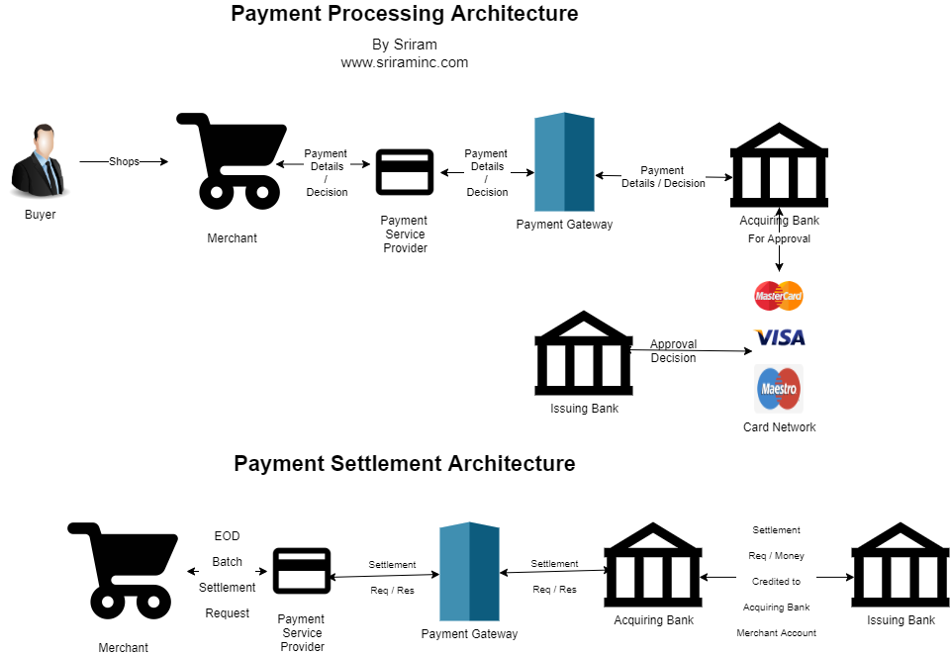

Key elements of payment systems

* **The customer**
* **The merchant**
* **The payment method**
* **The point-of-sale (POS) system**
* **The payment gateway**
* **The payment processor**
* **The acquiring bank, or acquirer**
* **The card network**
* **The issuing bank, or issuer**
* **Payment security**
* **Settlement and reconciliation**

Corporate Banking

Corporate banking Overview

Corporate banking is a very important division within many large commercial and bulge bracket banks; this team serves as a critical link between the commercial banking group and the capital markets/investment banking teams.

Role of Corporate Banking

**Corporate banking** teams provide financial services like cash management, payment processing, credit products, and hedging strategies to large corporations. Most of these corporations are publicly traded.

The term “corporate banking” is often used erroneously by non-finance people when talking about the provisioning of **banking services** to corporations (broadly); however, there is much more nuance when it comes to banking for businesses.

Retail vs corporate banking

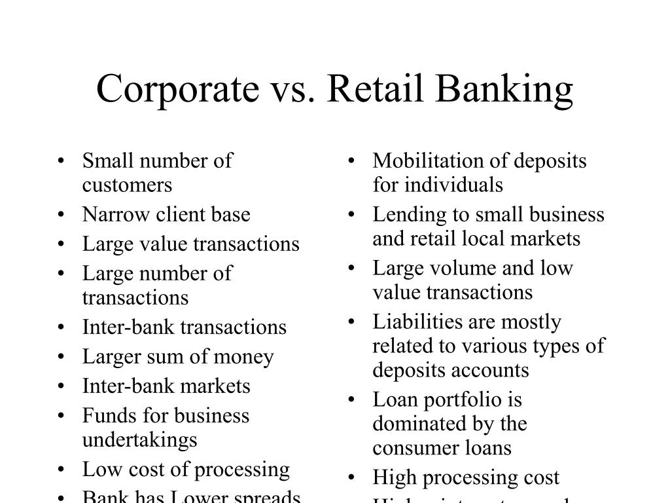

Customer Offerings

##### **Credit Management**

##### **Treasury and Cash Management Services**

##### **Equipment Lending**

##### **Risk Management**

##### **ASI**

##### **Employer Services**

##### **Commercial Services**

Type of Products

Corporate Banking offers a range of products and services to corporate and other financial institutions. These include

* Loans and other credit products
* Treasury and management services
* Equipment lending
* Commercial real estate
* Trade finance

Wealth Banking

Basics of Investing & Investing terminologies

Investing, broadly, is putting money to work for a period of time in some sort of project or undertaking in order to generate positive returns (i.e., profits that exceed the amount of the initial investment). It is the act of allocating resources, usually capital (i.e., money), with the expectation of generating an income, profit, or gains.

Some of the Basic terminologies are

* Stocks
* Bonds
* Funds
* Investment trusts
* Alternative investments
* Options and Other derivatives
* Commodities
* Dividends

How does compounding work

Compounding is the process in which an asset’s earnings, from either capital gains or interest, are reinvested to generate additional earnings over time. This growth, calculated using exponential functions, occurs because the investment will generate earnings from both its initial principal and the accumulated earnings from preceding periods.

Investment Products

* Stocks
* Bonds
* Mutual funds and ETFs
* Insurance Products such as Variable Annuities

Determining Investment style and avenues

Investment Styles

* Active management
* Passive management
* Growth investing
* Value investing
* Small cap Companies
* Large cap companies

Avenues

An investment avenue means investing money in something. It is often referred to as investment alternatives or investment strategies. There are numerous methods to categories investing possibilities.

Types of avenues of investment are

* Derivatives market
* Equity stocks
* Mutual fund investments
* Debentures/Bonds
* Fixed deposits
* PPF
* EPF
* NPS
* Property/Real estate
* Invest in gold
* Life insurance & General insurance

Creating a Portfolio

Building an investment portfolio can seem intimidating to those who are just beginning their investment journey. It can be challenging to set aside sufficient funds each month, while also budgeting for various expenses such as rent, equated monthly instalments (EMIs) for vehicles, and other obligations. However, the earlier you begin investing, the more time there is for your portfolio to mature and grow.

Here are some ways to build a robust investment portfolio

* Asset Allocation
* Financial goals
* Investment horizon
* Risk tolerance
* Risk diversification
* Plan for emergency and health insurance
* Invest in Mutual funds with systematic cash flow
* Backing up the portfolio with stop-loss order
* Study the market

Minimizing Risks

Risks are unavoidable in a portfolio. Hence, prudent investment stresses on risk management, to minimize an investor’s exposure to uncertainties through risk diversification. It is considered the most effective strategy for addressing all three risk categories.

Sovereign risks can be minimized by ensuring that your portfolio does not depend solely on government securities for stability. Diversifying into stocks also minimizes the chances of inflation risks while bonds and mutual funds are meant to offset the chances of loss of principal. At the same time, investors must also stay vigilant for market movements. Strategies like stop-loss orders are meant to limit one’s losses when they are unavoidable.

Another key aspect of portfolio risk management is its periodic review and rebalancing. Our risk tolerance can change with time and as per our income, circumstances, or age. For instance, you will be less willing to take risks with children or near retirement age. It’s important to assess your portfolio to determine the distribution between high-risk and high-return investments like stocks, and low-risk but low-return assets like bonds or fixed-income securities.

A periodic review is also necessary to keep track of your investments and the yearly growth of your portfolio. With time you can gain a finer insight into the behavior of your portfolio and how best to improve it. More importantly, it ensures that your portfolio keeps pace with your changing requirements.

Investment returns

A return, also known as a financial return, in its simplest terms, is the money made or lost on an investment over some period of time.

A return can be expressed nominally as the change in dollar value of an investment over time. A return can also be expressed as a percentage derived from the ratio of profit to investment. Returns can also be presented as net results (after fees, taxes, and inflation) or gross returns that do not account for anything but the price change. It even includes a 401(k) investment.

Measurement of Risks

Risk in investment is measured by the amount of volatility , that is the difference between actual returns and average returns. Some common measurement of risks are

* Standard deviation
* Sharp ratio
* Beta
* Value at risk(VaR)
* Conditional value at risk(CvaR)

SIP - Basic concepts and classification

A SIP is a systematic approach to investing and involves allocating a small pre-determined amount of money for investment in the market at regular intervals (usually every month)

The SIP route is the preferred way of investing in stocks and Mutual Funds because it allows you to participate in the market while managing risk better

Classification of SIP

* Regular SIP
* Top-up SIP
* Flexible SIP
* Perpetual SIP
* Trigger SIP
* SIP with insurance
* Multi SIP

Mutual Funds- Basic concepts and classification

Mutual fund is a financial instrument that pools money from different investors. The pooled money is then invested in securities like stocks of listed companies, government bonds, corporate bonds, and money market instruments

Classification of Mutual funds

* Equity Mutual funds
* Debt Mutual funds
* Growth oriented schemes
* Income oriented schemes
* Balanced fund
* Liquid fund